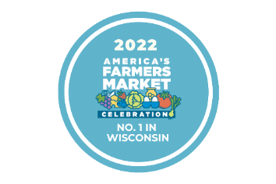
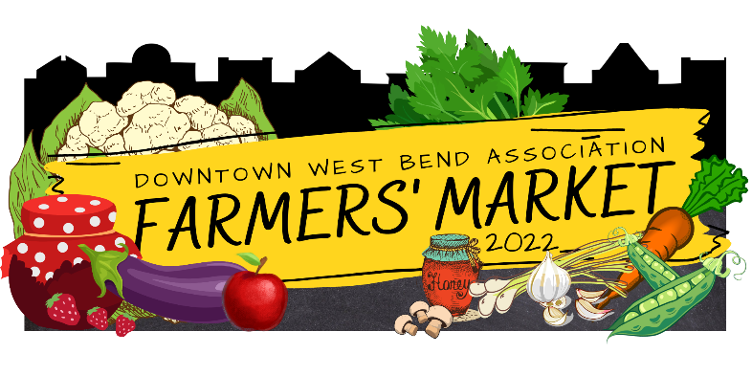

To Our Entertaining Friends:

Musical entertainment at the Downtown West Bend Farmers’ Market helps add to the success it is. Music is enjoyed by all who come and visit the market. During the season I am always complimented on the variety of musical talent we have at the market.

Thanks for your contribution.

It is again time to schedule the entertainment for the 2023 season. It’s a great way to get exposure for your group and share your talent with a unique audience. This is a great opportunity for you to show off your talents and be a part of the #1 Market in the State!

Due to the Construction on Main Street during our West Bend Farmers Market season, we will be temporarily located at 320 S 5th Ave. (We will be making a horseshow shape around The Towers Heritage Center) So our stalls will be on 5th Ave, 6th Ave, and Poplar Street. Unfortunately, due to the change in location we will not have access to electricity in 2023.

If you are interested or know of someone who is, please sign up!

The Farmers' Market is every Saturday from May 20th through October 21, 2023. The Market is open 7:30am-11:00am. The time scheduled for music is 8:00am – 11:00 am. We expect all groups to remain playing until 11am. Musical groups need to bring their own equipment and necessities. You must have any vehicles moved outside the market by 6:50 so if you need to bring in heavy equipment it is suggested that you come early to set up.

We look forward to helping promote local talent at our Farmer’s market. We can be reached by email to answer any questions you may have regarding the Farmers' Market and the entertainment.
If you have any questions or comments, please email me directly.

Thank you for your time and talent!

Please complete the form and return it by March 4, 2023.

Tomasa Lane
Market Coordinator
120 N Main Street, Ste 120
West Bend, WI 53095
events@downtownwestbend.com
262-338-3909

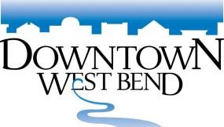
2023 Farmers' Market
Entertainment Reservation Form

Name of Musical Group____________________________________________________________________________

Contact Person_____________________________________________________________________________________

Address_______________________________________________City/Zip______________________________________

Contact Phone____________________ Email___________________________________________________

Where is your group from? __________________________________________________________________________

Type of music_____________________________________ # of members in your band/group _____________

Facebook handle ___________________________________ website _______________________________________

Please check which location your group is requesting to be performed at (NOTE there is NO ELECTRIC AT ANY OF THE LOCATIONS).

______ Location One: TBA
______ Location Two: TBA
______ Location Three: TBA

Please check up to 12 dates your group is interested in performing at the Market. (#1 being your most desired date) The number of times your band will play is determined by how many groups are interested in performing and which dates we have available UNLESS you indicate that you only want to play one date.

MAY |  | JUNE |  | JULY |  | AUG |  | SEPT |  | OCT
 | 20 |  | 3 |  | 1 |  | 5 |  | 2 |  | 7
 | 27 |  | 10 |  | 8 |  | 12 |  | 9 |  | 14
 |  |  | 17 |  | 15 |  | 19 |  | 16 |  | 21
 |  |  | 24 |  | 22 |  | 26 |  | 23
 |  |  |  |  | 29 |  |  |  | 30

_______ Our group may be available other dates - If you have a cancellation, just give us a call. (If your group can get together on short notice and you might be able to help us out, please check this.)

Please complete this form by March 4, 2023 and send to:

Downtown West Bend Association 120 N. Main Street, Suite 120 West Bend WI 53095
Phone: 262-338-3909 Email: events@downtownwestbend.com

