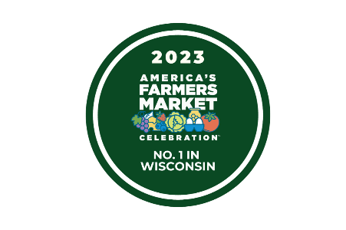
Downtown West Bend Farmers' Market 2024 Contract Agreement (Please print clearly - Fill in all spaces)
For office use: Stall(s) #:
Fees:

Vendor Information

Vendor Name Contact Person

Business Name (if different than vendor name)

Address City Zip Code

Business Phone Cell Phone

Email

Website Facebook Yes No

Vehicle type: Vehicle license plate number:

Stall Rentals/Fees

Stalls Requested (not to exceed 3 stalls, unless approved first) ($300.00 per stall)

Yes, I would like to attend the early Market session (May 18th and 25th) ($15.00 per stall per day)

$ Total Due

*Remember vehicles must either fit in your rented stall along with your items OR you must park it outside of the market area. Vehicle & products may not exceed the space you rented. Additional spaces may not be rented just for vehicle parking. Violators may be removed from market at the discretion of the DWBA.

Pre-Planned Absences

Please circle the dates you will be absent from the regular market in the 2024 season:

6/1 |  | 6/8 | 6/15 | 6/22 | 6/29 | 7/6 | 7/13
7/20 |  | 7/27 | 8/3 | 8/10 | 8/17 | 8/24 | 8/31
9/7 |  | 9/14 | 9/21 | 9/28 | 10/5 | 10/12 | 10/19
10/26
If you are tentative on a date, please mark with a question mark (?)

Products for Sale

The products I will offer for sale will be locally grown at my farm/property/rented land here in Wisconsin and only at the following location/s (include city, state, and zip):

(Any exceptions require prior written permission from the DWBA.)

Items I plan to grow/produce and would like to sell this year will include the following: (please print- be specific, include all products and if you need more room for listing products please use back of sheet.)

1. 2. _ _ 3. _ 4. _

5. 6. _ _ 7. _ 8. _

9. _ 10. 11. _ 12.

13. 14. 15 16.

17. 18. _ 19. _ 20. _

21. 22. _ 23. _ 24. _

Please provide a copy of the required licenses as listed below. The license must be current for the 2024 season.

*If a copy of your state permit or license is not on file in our office, you will not be allowed to sell at the market.

- Copy of State of Wisconsin Food Processing License if selling baked, canned goods, etc.
  - Note: If you are processing any acidic foods such as tomatoes, you must also have taken the acidic food processing class
  - We will NOT be accepting pickle bill processing at the Downtown West Bend Farmers Market. If you process canned goods of any sort, you must have a processing license.
- Copy of State of Wisconsin Department of Agriculture Retail License if selling eggs (shell egg endorsement)
- Copy of State of Wisconsin Department of Agriculture Official Meat Establishment License if selling meats
- Copy of State of Wisconsin Department of Agriculture Dairy License if selling dairy
- Copy of your local state on site food processing mobile restaurant license if you are processing any foods on sight such as egg rolls, popcorn, cutting food samples etc.
- Copy of State of Wisconsin Pet Food/treat license.
- Copy of your current Liability Insurance with West Bend Farmers Market as the certificate location.
- A Copy of your seller’s permit
- A copy of your S240 form

I have read and agree to the terms of the enclosed Downtown West Bend Association 2024 Farmers' Market Rules and Regulations.

Signature of Vendor Date

Return this signed agreement with a copy of licenses (as required) and a check payable to:

Downtown West Bend Association 120 N. Main St. Suite, 120
West Bend, WI 53095

Reminders:
All Payments, Paperwork, Licenses, and Insurance are due before you will receive stall confirmation.

